BACKEND DEVELOPMENT

* Is a separate technology
* Server : software that serves. Not a big computer.
* 2 components master –
  + A programming lang
  + A database
* No need to learn node.js first

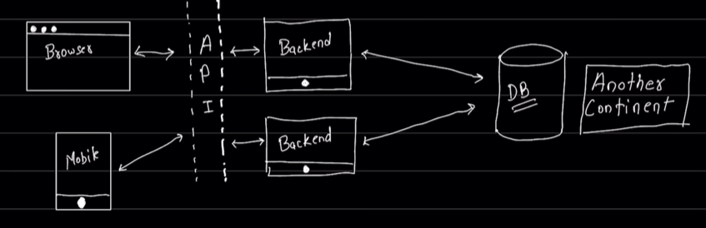

* Directory structure:
  + Src
    - Index.js – entry point for application, DB connects
    - App – config, cookie,, urlencode
    - Constants – enums, DB-name
  + DB – actual code jo DB se connect karta hai
  + Models – schema of data (structure of data)
  + Controllers - methods/functions
  + Routes – routing of the web page
  + Middleware -
  + Utils – utility, jaise mail bhejna hai, functionality, file upload and all that
  + More (depends) – kya project hai and all
* Ek baar backend samjh aa gaya to bahut ache frontend dev bhi ban jate ho. Its difficult at first but after it becomes easy.

**HOW TO DEPLOY BACKEND CODE IN PRODUCTION**

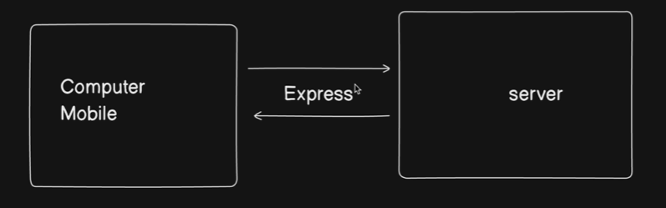

* Jo request computer mobile se aati hai server ko, vo multiple tarah ki requests ho sakti hai. Like, koi entry deni hai, ya save karni hai, all that
* Abhi we will send a “get” request from mobile to server.
* What is get request? – get request is the simple request that u are sending from your webs browser to the server.
* We can make a server using express.js
* When a user sends a request from their browser, to the server, it listens to the request
* Then handle the request.